Renju lesson on February 1, 2001

Hello all! Happy Chinese New Year! Welcome to Online Renju Class.
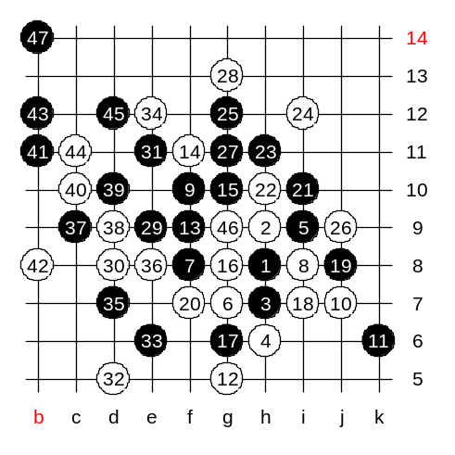
Lets continue with d8. Last week we tried some incorrect 10th moves, they were included to your last week homework. Where is the correct 10th move? J7 – correct!
How about if white plays the same gambling move g5? Can anyone show black win moves here? Most of you said f9. Lets test. In that first way of attack black won. Probably, because white did not defend in a best way.

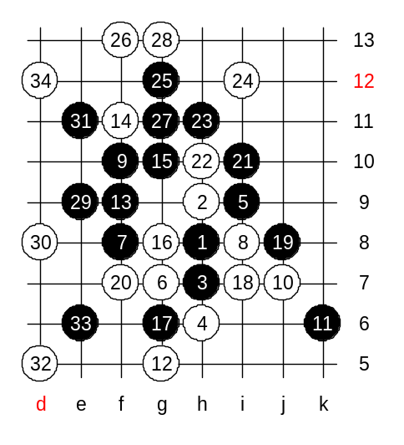
Lets play another 26th move. Perhaps it is stronger for white.
We have reached to the position where black win is questionable and even if there is a win somewhere, it is very difficult. As you see, the f4 point gives white helpful defense key, and black attack is complicated. Move 10-i7 gave white new defense ideas, but actually it has a disadvantage too. The disadvantage is that white will have no chance to use k6 point, and therefore black can use another way for winning attack, not 13-f9.

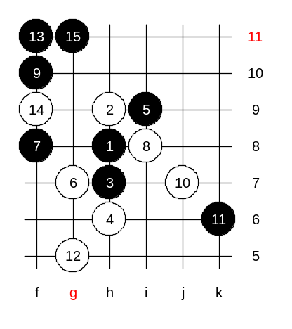
Black has easy win with 13-f11. After 15-g11 black controls all white structures and wins easily. You may wonder why black could not play in the same way in our advanced homework last week. The difference is that in that case white could play k6 and catch easy 3x3.

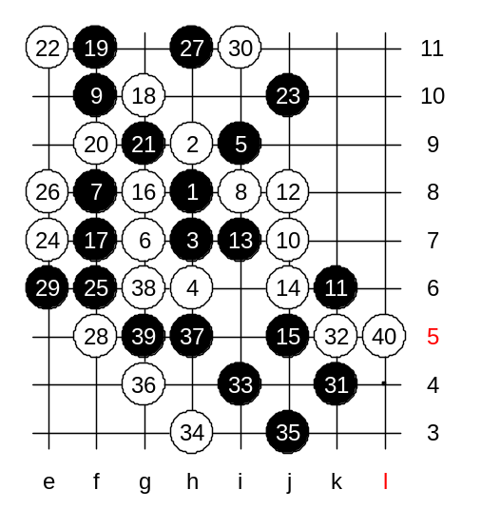
It is time to play the correct 12th move. You all know where is it. Yes, 12-j8. Black’s 13-i7 is forced. White has two ways to block that three. The traditional theory says 14-j6, but Nakamura surprised me in the 2nd game of the match with 14-g9. It is not easy to comment which one gives black better attack. First, lets play according to my 5th game with Nakamura. The 23-j10 is the strongest move. In the old times 23-e7 was also quite popular, but by now white win is almost sure in that case. In case of 23-j10 then most popular answer is 24-e7. The 25-f6 is the tricky move. Nakamura played carelessly 26-e8 and got sure loss position. Nakamura assumed that black would block from d7 but actually black can block from upper side. Now, after 27th move, black suddenly has winning position in both lower and upper side, whereas white has no VCT.
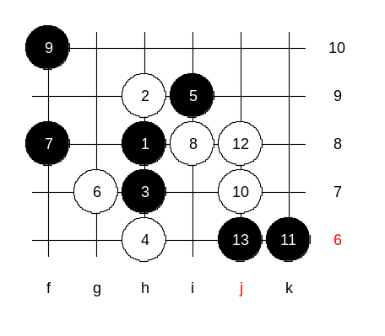
Now there are 40 stones on the board, all is exactly like in the game Meritee-Nakamura. I could not find black win in that game. But you can. This is the advanced level homework. Please find the black sure win.

This is the medium level homework. Please find the white win.
The class is over now. Thank you all for coming! See you next Thursday!

